Spike Derivative Report with Speech data:

If we ignore the refractory period, the estimated error can be big!

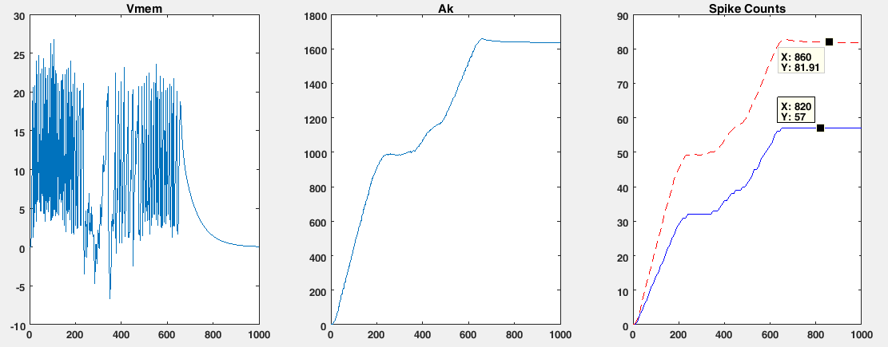

Treat t_last as t_last + t_refractory, we will solve the problem:

